# Guía para permitir CORS y evitar Rastreo y bloqueo en testing (Firefox)



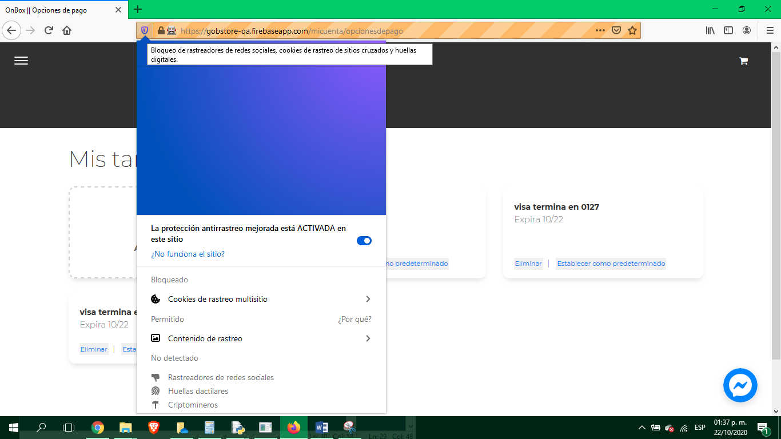

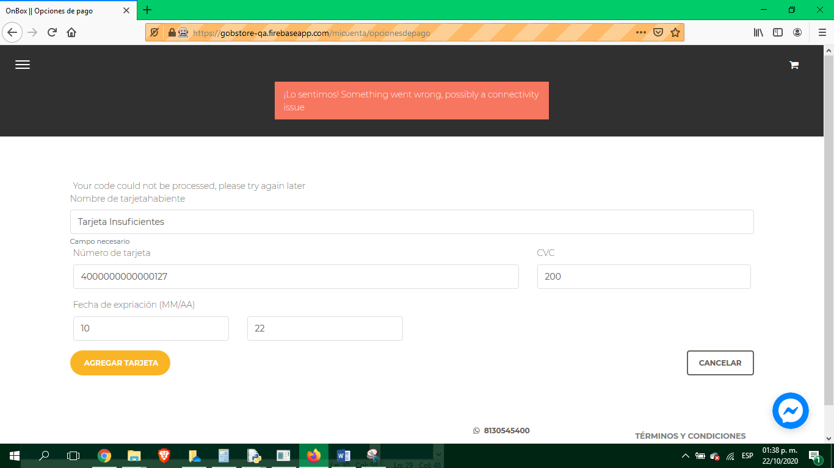

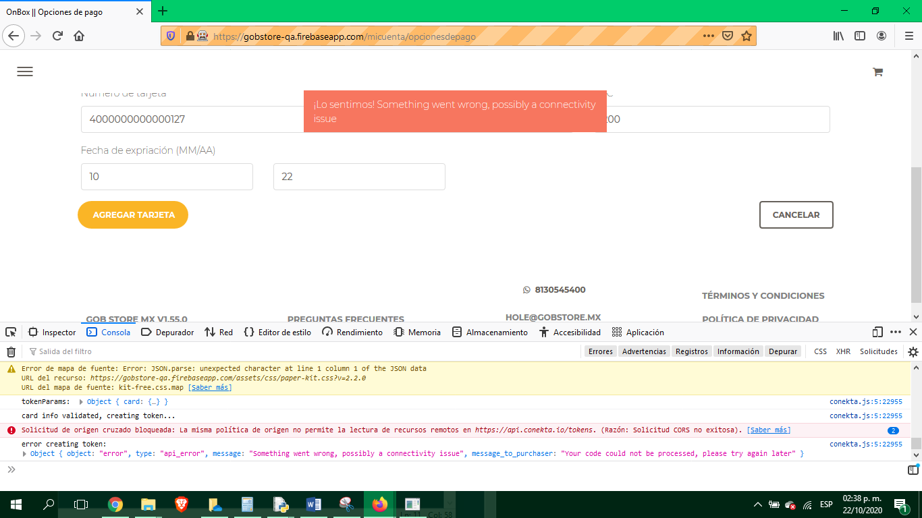

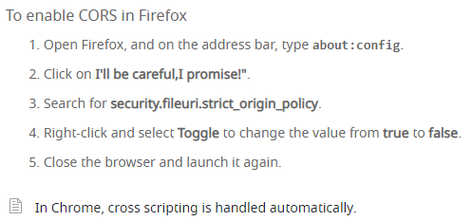





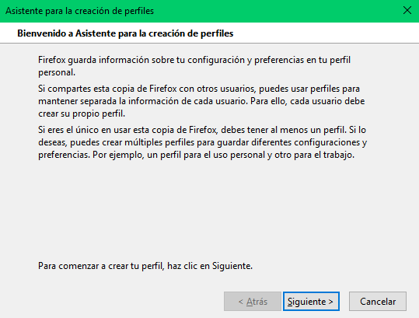

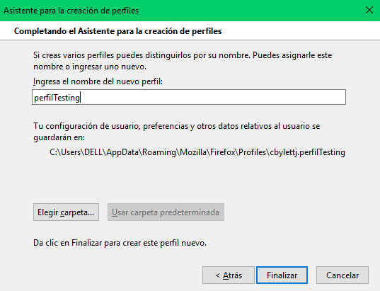

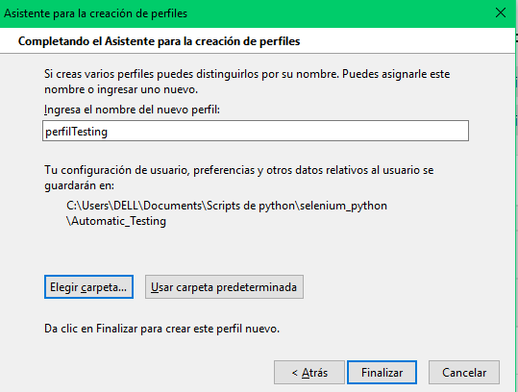

<https://support.mozilla.org/es/kb/usar-el-administrador-de-perfiles-para-crear-y-eli#w_removing-a-profile>

#firefox_profile = webdriver.FirefoxProfile()

#firefox_profile.set_preference("browser.privatebrowsing.autostart", True)

#firefox_profile.set_preference("privacy.socialtracking.block_cookies", False)

#firefox_profile.set_preference("privacy.trackingprotection.socialtracking", False)

#firefox_profile.set_preference("security.fileuri.strict_origin_policy", False)

#privacy.trackingprotection.socialtracking.enabled

#privacy.socialtracking.block_cookies.enabled

driver = webdriver.Firefox(firefox_profile=firefox_profile,executable_path=r"C:\Users\DELL\Documents\Scripts de python\selenium_python\geckodriver.exe")

#driver = webdriver.Firefox(executable_path=r"C:\Users\DELL\Documents\Scripts de python\selenium_python\geckodriver.exe",firefox_profile=firefox_profile)

#driver = webdriver.Firefox(firefox_profile=profile,executable_path=gecko_path)

#driver = webdriver.Firefox(executable_path=r"C:\Users\ricar\AppData\Local\Programs\Python\Python38\geckodriver.exe")

driver.get("https://gobstore-qa.firebaseapp.com/")

#firefox_profile = webdriver.FirefoxProfile()

#firefox_profile.set_preference("browser.privatebrowsing.autostart", True)

#driver = webdriver.Firefox(firefox_profile=firefox_profile)

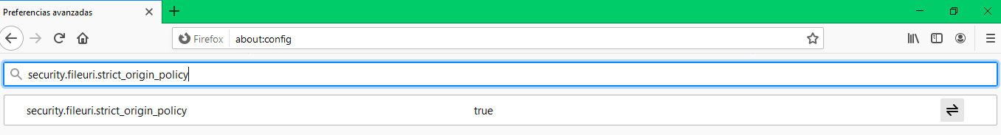

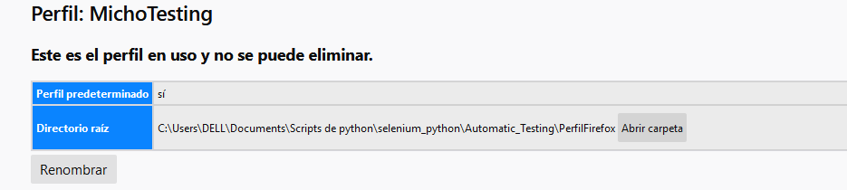

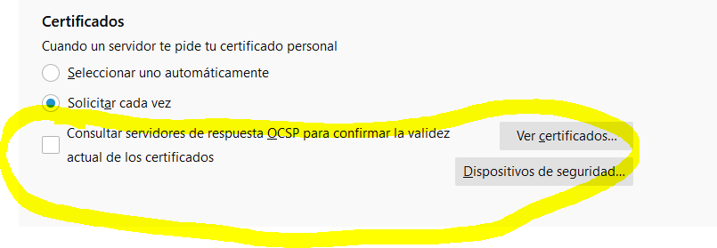

**Configuración FINAL:**

**global driver**

**fp = webdriver.FirefoxProfile('/Users/DELL/Documents/Scripts de python/selenium_python/Automatic_Testing/PerfilFirefox')**

**driver = webdriver.Firefox(firefox_profile=fp,executable_path=r"C:\Users\DELL\Documents\Scripts de python\selenium_python\geckodriver.exe")**